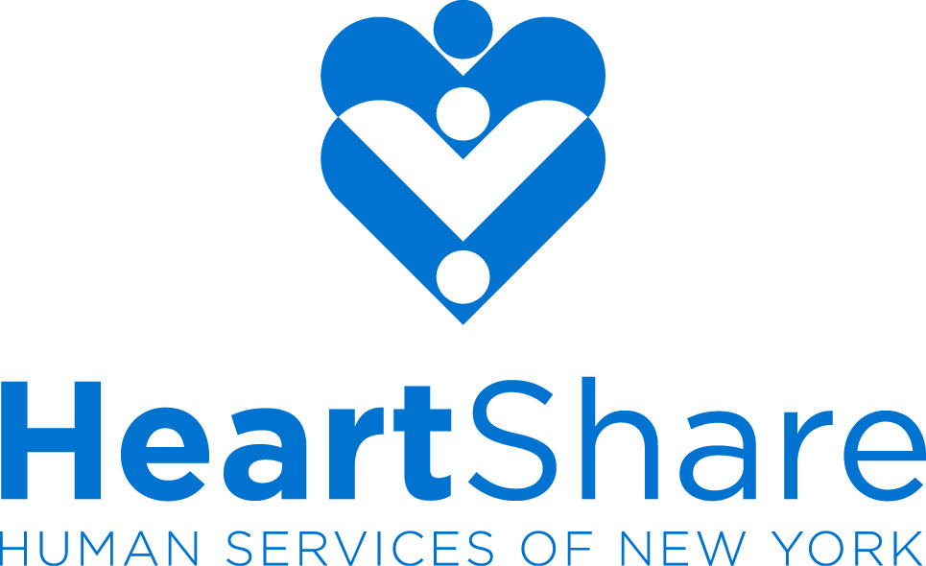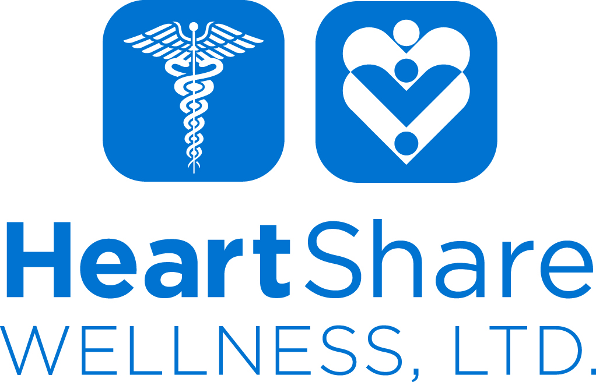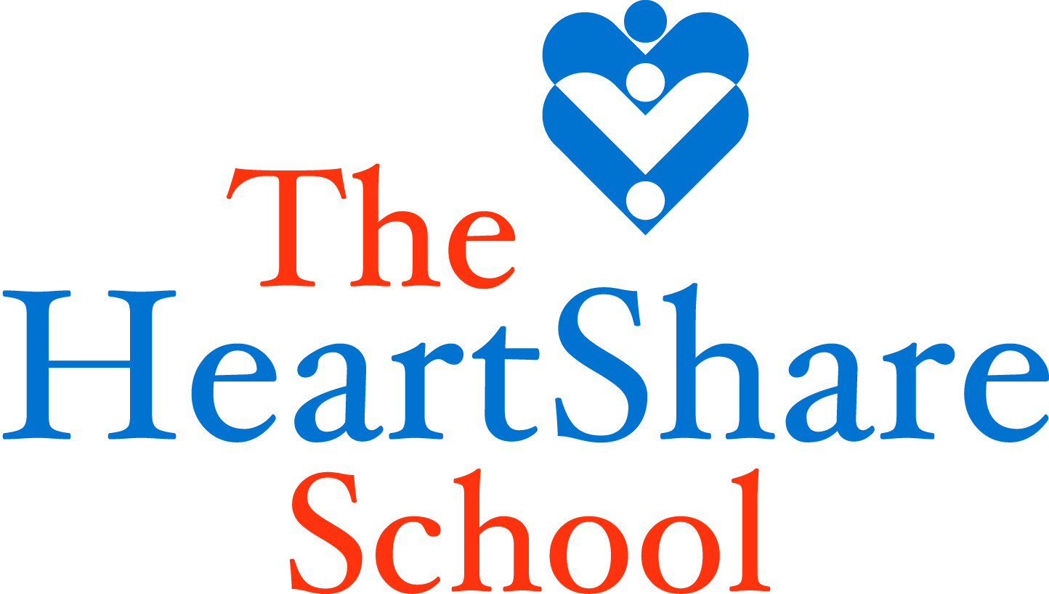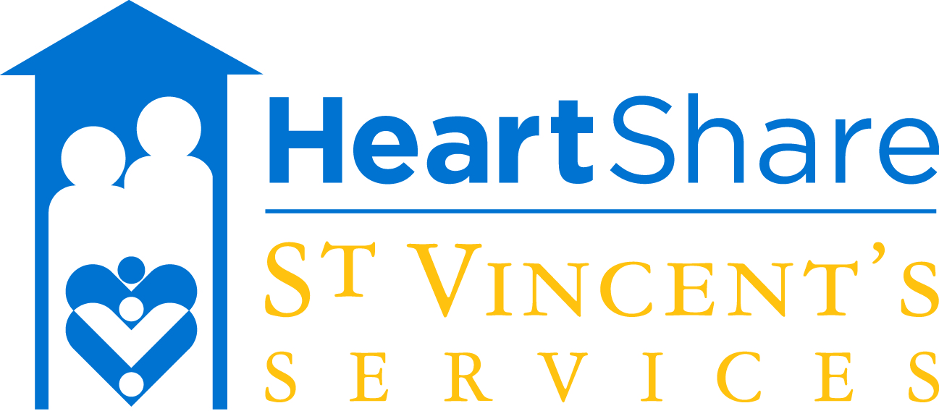

Communications Department | 12 MetroTech Center, 29th Fl. | Brooklyn, NY 11201 | 718-422-3208 | www.heartshare.org

MEDIA CONSENT FORM FOR CHILDREN & YOUNG ADULTS

I, ______________________________________________, am the parent/guardian of __________________________________________ (referred to as “my child”), who resides at __________________________________________, and participates in programs and activities with HeartShare Human Services of New York and/or its affiliates, HeartShare Wellness, Ltd., The HeartShare School and HeartShare St. Vincent’s Services.

I hereby consent to my child’s participation in interviews, the use of quotes and the taking of photographs and/or videos of him/her on behalf of HeartShare Human Services of New York and its affiliates. I also grant the right to edit, use, and reuse said products for non-profit, non-commercial purposes, including in print, online, social media and all other forms of media. I consent to the use of my child’s name and association with HeartShare and its affiliates for the foregoing purposes. I give this authorization without expectations of compensation.

If I no longer want my quotes, photos or videos used, I will make that request in writing to: HeartShare Human Services of New York, Communications Department, 12 MetroTech Center, 29th Floor, Brooklyn, NY 11201.

Signature: _______________________________________ Date: ____________________

